Average First and Last Frost Dates  
for Illinois

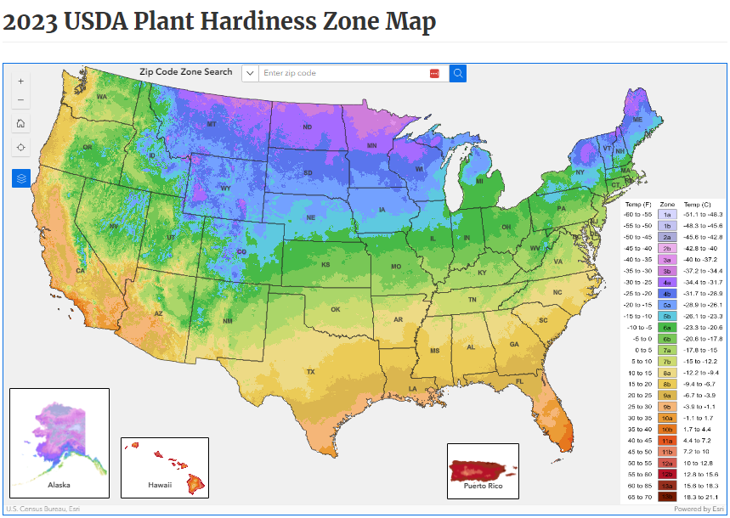

Source: USDA, Arborday.org

|  |  |  |
| --- | --- | --- |
| **City** | **Spring** | **Fall** |
| Aledo | 4/29 | 10/14 |
| Cairo | 4/8 | 10/26 |
| Chicago | 4/17 | 11/1 |
| East St. Louis | 4/14 | 10/21 |
| Peoria | 4/23 | 10/18 |
| Rockford | 4/30 | 10/12 |
| Springfield | 4/20 | 10/17 |
| Windsor | 4/22 | 10/17 |

Planting from Seeds

Source: "*The Old Farmers Almanac --* [*https://www.almanac.com/gardening/frostdates*](https://www.almanac.com/gardening/frostdates)

* Seeds are classified by kind and cultivar
  + Kind – seeds from plants of a single perennial, such as coneflower, or zinnia
  + Cultivar – different varieties of a single kind, generally differing in one or more features

Growing Media and Their Characteristics

Echinacea, Hot Lava

Echinacea, Tiki Torch

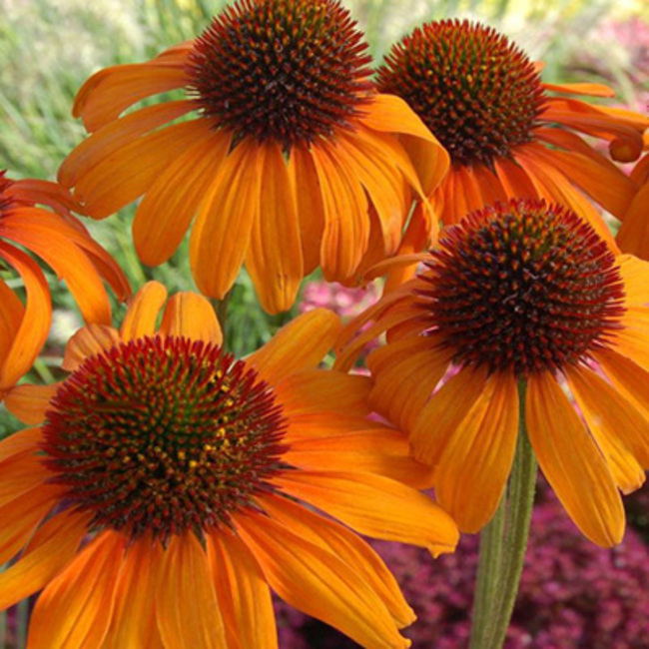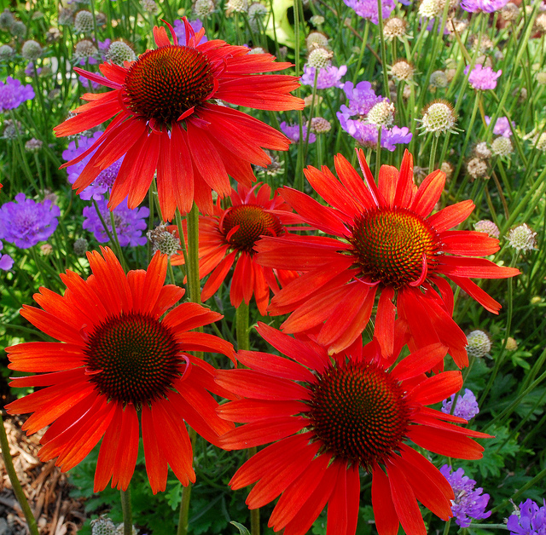

Kind and Cultivar

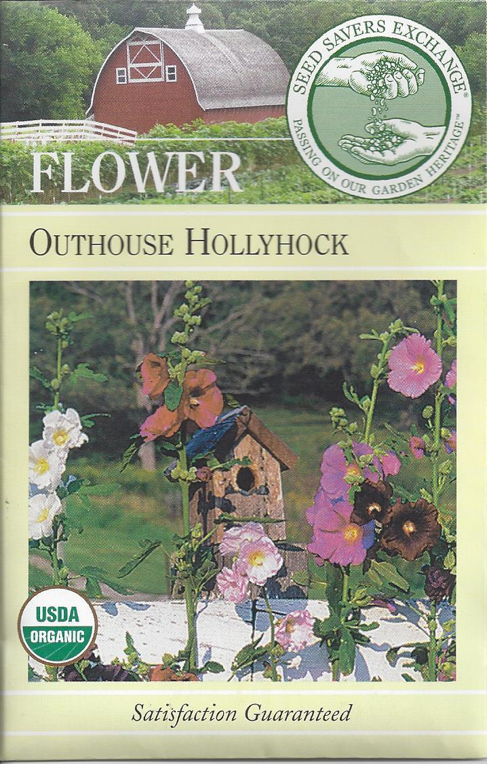

Packaging Information

Planting Directions

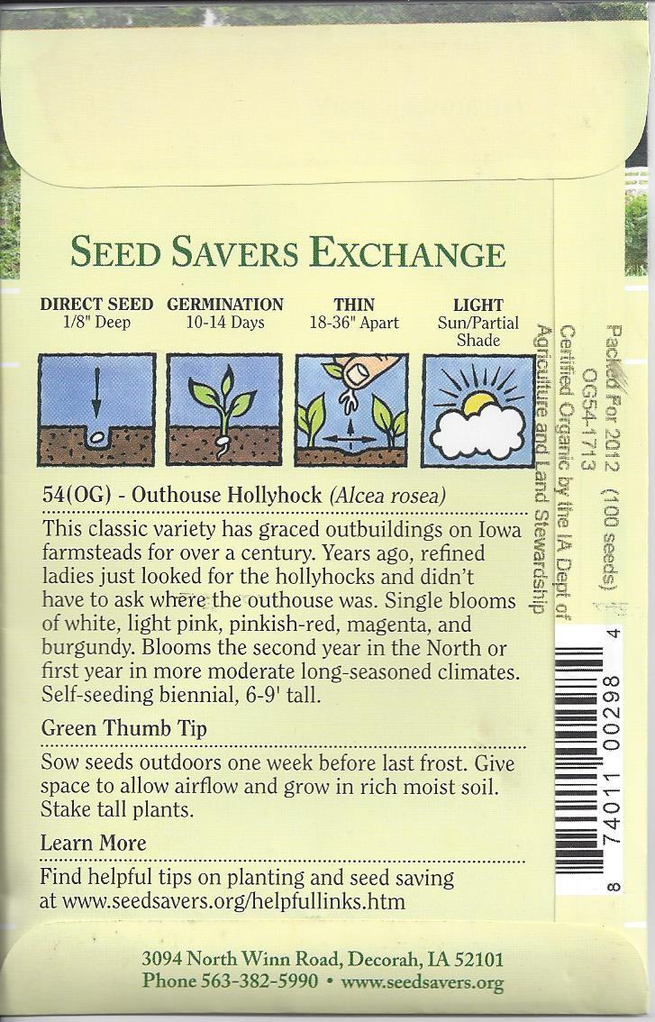

|  |  |
| --- | --- |
| **Growing Media** | **Characteristics** |
| Peat  Perlite | * An accumulation of partially decayed vegetation * Forms in wetlands, bogs, moors, muskegs, pocosins, mires, and peat swamp forests * Used in soil mixes for its water-holding capabilities |
|  | * A light weight expanded volcanic material mined from lava flows * Has no fertility value, but excellent water-holding capacity * Provides both aeration and water-holding ability |
| Vermiculite | * A light weight expanded mica that absorbs considerable amounts of water * Contains large amounts of available magnesium and potassium * Provides both aeration and water-holding ability |
| Sand | * A naturally occurring granular material composed of finely divided rock and mineral particles * Provides aeration to soil mixes * Should not be used alone as a growing medium because its water-holding capability is poor |

Three Types of Mineral Soils

|  |  |
| --- | --- |
| **Soil Type** | **Characteristics** |
| Sandy Soil  Loam Soil | * Contain <15% silt or clay * Well-aerated * Dry out and warm up quickly * Low in fertility |
|  | * Contain <20% clay, 30-50% silt, and 30-50% sand * Ideal for most vegetables |
| Clay Soil | * Contain 20-30% clay * Retain water and dry slowly; difficult to cultivate properly * Poor root growth due to small air spaces * Crust easily, reducing plant growth, since they have difficulty breaking through the surface |

Examples of Organic Matter

How to Read a Bag of Fertilizer

Leaf Mold

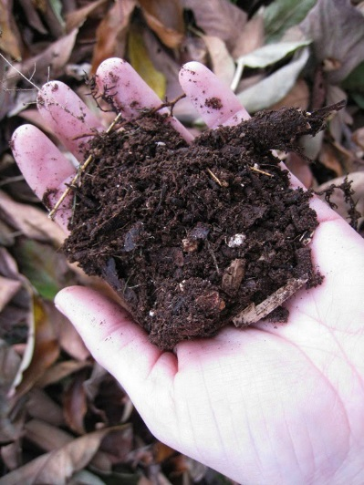

Cotton Burr Compost

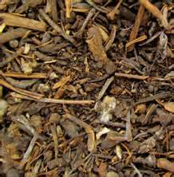

Peat Moss

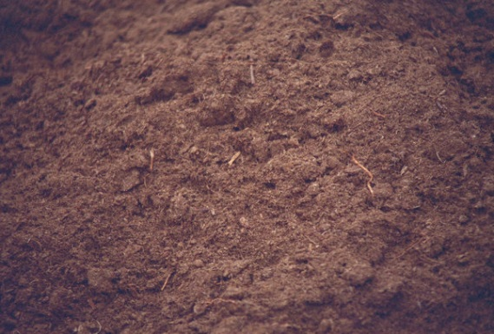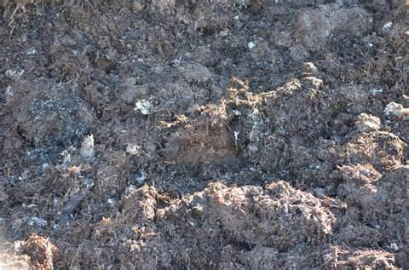

Mushroom Compost

Manure

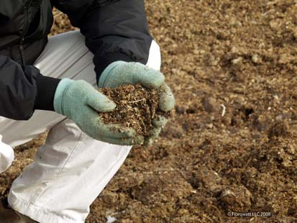

Corn Cobs

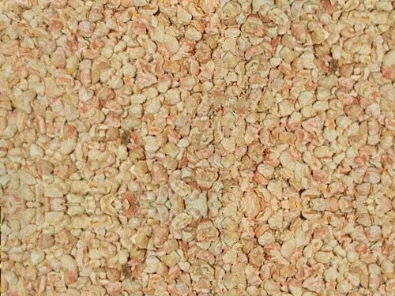

Essential Plant Nutrients

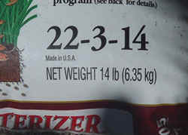

% Nitrogen

% Phosphorus (as phosphorus pentoxide P2O5)

% Potash (Potassium as potassium oxide K2O)

|  |  |  |  |
| --- | --- | --- | --- |
| **Nutrient** | **Function** | **Deficiency Symptoms** | **Toxicity Symptoms** |
| Carbon, Hydrogen, and Oxygen | * Makes up the bulk of the plant tissue * Plant obtains carbon and oxygen from the air and hydrogen from the water, no need to supplement | * N/A | * N/A |
| Nitrogen | * Nitrogen is a part of all living cells and is a necessary part of all proteins, enzymes and metabolic processes involved in the synthesis and transfer of energy. * Nitrogen is a part of chlorophyll, the green pigment of the plant that is responsible for photosynthesis. * Helps plants with rapid growth, increasing seed and fruit production and improving the quality of leaf and forage crops. * Nitrogen often comes from fertilizer application and from the air (legumes get their N from the atmosphere, water or rainfall contributes very little nitrogen) | * Chlorosis (yellowing of leaves) * Small leaves * Spindly plants | * Leaves that are dark green, thick and brittle * Lots of stems and leaves, but little fruit * Calcium deficiency |
| Phosphorous | * Like nitrogen, phosphorus (P) is an essential part of the process of photosynthesis. * Involved in the formation of all oils, sugars, starches, etc. * Helps with the transformation of solar energy into chemical energy; proper plant maturation; withstanding stress. * Effects rapid growth. * Encourages blooming and root growth. * Phosphorus often comes from fertilizer, bone meal, and superphosphate. | * Dark blue-green or reddish purple leaves * Slow growth * Decreased fruit yields | * Zinc, iron, and copper deficiencies |
| Potassium | * Potassium is absorbed by plants in larger amounts than any other mineral element except nitrogen and, in some cases, calcium. * Helps in the building of protein, photosynthesis, fruit quality and reduction of diseases. * Potassium is supplied to plants by soil minerals, organic materials, and fertilizer. | * Margins of leaves turn yellow with brown regions * Slow growth | * Nitrogen deficiency * Poor uptake of magnesium and calcium |

|  |  |  |  |
| --- | --- | --- | --- |
| **Nutrient** | **Function** | **Deficiency Symptoms** | **Toxicity Symptoms** |
| Calcium | * Calcium, an essential part of plant cell wall structure, provides for normal transport and retention of other elements as well as strength in the plant. It is also thought to counteract the effect of alkali salts and organic acids within a plant. * Sources of calcium are dolomitic lime, gypsum, and superphosphate. | * Inhibition of bud growth * Rotted black roots * Blossom end rot on fruits * Abnormally green leaves * Cupping of mature leaves | * High soil pH, which makes other nutrients unavailable to the plant * Interference with magnesium absorption |
| Magnesium | * Magnesium is part of the chlorophyll in all green plants and essential for photosynthesis. It also helps activate many plant enzymes needed for growth. * Soil minerals, organic material, fertilizers, and dolomitic limestone are sources of magnesium for plants. | * Growth reduction * Yellowish, bronze, or reddish color of older leaves, while veins remains green * Leaf margins may curl downward or upward with a puckering effect | * Interference with calcium uptake * Necrotic spots and brown veins in older leaves |
| Sulfur | * Essential plant food for production of protein. * Promotes activity and development of enzymes and vitamins. * Helps in chlorophyll formation. * Improves root growth and seed production. * Helps with vigorous plant growth and resistance to cold. * Sulfur may be supplied to the soil from rainwater. It is also added in some fertilizers as an impurity, especially the lower grade fertilizers. The use of gypsum also increases soil sulfur levels. | * General yellowing of the young leaves then the entire plant * Veins lighter in color than adjoining interveinal area * Roots and stems are small, hard and woody | * Usually caused by air pollution |
| Boron | * Helps in the use of nutrients and regulates other nutrients. * Aids production of sugar and carbohydrates. * Essential for seed and fruit development. * Sources of boron are organic matter and borax | * Failure to set seed * internal breakdown of fruit or vegetable * Death of apical buds, giving rise to witches broom * Failure of root tip to elongate normally * Young leaves become thick, leathery, and chlorotic * Rust colored cracks and corking on young stems, petioles and flower stalks (e.g. heart rot of beets, stem crack of celery) * Breakdown occurs at the base of the youngest shoots | * Necrotic spots on tips and edges of leaves, combining to form a marginal scorch |
| **Nutrient** | **Function** | **Deficiency Symptoms** | **Toxicity Symptoms** |
| Copper | * Important for reproductive growth. * Aids in root metabolism and helps in the utilization of proteins. | * New growth small, misshapen, wilted; may be found in some peat soils * In some species young leaves may show interveinal chlorosis while tips of older leaves remain green | * Misshapen and wilted plants * Chlorosis in the veins, tips remain green |
| Chloride | * Aids plant metabolism. * Chloride is found in the soil. | * Wilted leaves which become bronze then chlorotic then die * club roots | * Salt injury * Leaf burn |
| Iron | * Essential for formation of chlorophyll. * Sources of iron are the soil, iron sulfate, iron chelate. | * Interveinal chlorosis primarily on young tissue, which may become white | * N/A |
| Manganese | * Functions with enzyme systems involved in breakdown of carbohydrates, and nitrogen metabolism. * Soil is a source of manganese. | * Interveinal chlorosis with smallest leaves remaining green producing a checkered effect * Grey or tan spots usually develop in chlorotic areas * Dead spots may drop out of the leaf * Poor bloom size and color; induced by excessively high pH | * Growth reduction * Brown spotting on leaves * Interference with iron absorption |
| Molybdnum | * Helps in the use of nitrogen * Soil is a source of molybdenum. | * Interveinal chlorosis on older or midstem leaves * Twisted leaves (whiptail) * Marginal scorching and rolling or cupping of leaves * Nitrogen deficiency symptoms may develop | * Increased yellow or purple color in leaves |
| Zinc | * Essential for the transformation of carbohydrates. * Regulates consumption of sugars. * Part of the enzyme systems which regulate plant growth. * Sources of zinc are soil, zinc oxide, zinc sulfate, zinc chelate. | * Young leaves are very small, sometimes missing leaf blades * Short internodes * Distorted or puckered leaf margins; interveinal chlorosis | * Poor germination * Severe stunted growth * Wilting of older leaves * Chlorosis * Can be caused by galvanized metal |

Perennial Insect Pests

Source: North Carolina Dept. of Agriculture; University of North Carolina

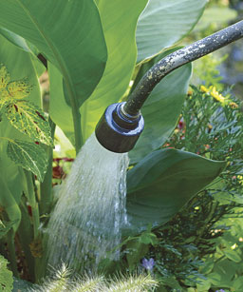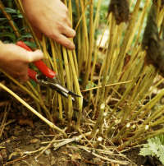

1. Decide which plants you wish to save, discard, or replant elsewhere
2. Water the bed a few days before attempting to dig and divide
3. Prune the perennials down to six inches above ground

How to Divide Perennials

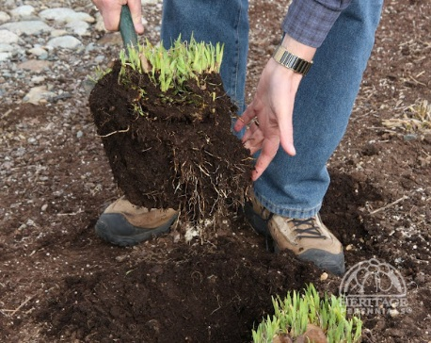

1. Dig out the entire clump as completely as possible
2. Use hands, trowel or shovel to separate the clumps
3. If clump stubbornly resists division, insert two spading forks back to back, and press handles together

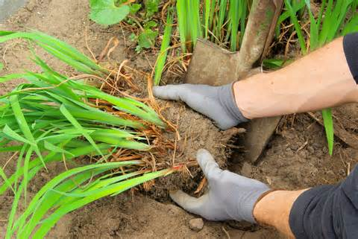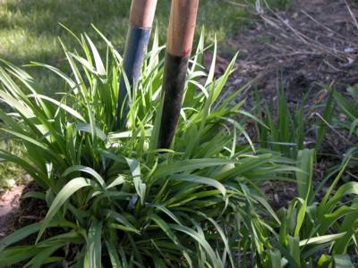

How to Divide Perennials

|  |  |
| --- | --- |
| **Insect Pest** | **Characteristics and Control** |
| Aphid | * Small, pear shaped, soft-bodied, 1/8 inch long * Feed by sucking the juices from leaves and stems * Secrete a syrupy substance called honeydew, which supports mold growth * Controls * Natural enemies (lady beetles, lacewings, parasitic wasps) |
| Cutworm | * Blackish, thick-bodied, and up to 1 inch long * Active at night * Young larvae climb plants and eat leaves; older caterpillars shear through the stem * Controls * Remove weeds and plant residue * Tilling soil before planting – will expose and kill overwintering larvae * Cardboard collars * Insecticide |
| Earwig | * Hard-bodied, reddish brown, with pincher on end of abdomen * Mostly feed on decaying organic matter but will occasionally eat the leaves of lilies, zinnias, and other flowers * Control * Insecticide (do not spray the flowers) |

|  |  |
| --- | --- |
| **Insect Pest** | **Characteristics and Control** |
| Iris Borer | * Moth is brownish with a 1¼” wingspan * Larvae are flesh-pink colored * In the spring, larvae enter leaves and feed on the tissue, giving the leaves a water-soaked appearance * Larvae then tunnel down into rhizome * Transmit bacterial soft rot * Control * Sanitation |
| Japanese Beetle | * 3/8” to ½” metallic green, with copper colored wing covers * Present from July to mid-August * Grubs feed on grass roots * Adults feed on gladiola, coneflower, dayliliy, hollyhock, hibiscus, and other perennial plants * Control * Hand picking * Pesticides |
| Slug | * Moist, soft-bodied animals * Feed mainly at night * Eat holes in leaves and leave silvery slime trails * Hide under debris during day * Control * Pans filled with beer * Slug baits |
| Sowbug/Pillbug | * Snall, grayish, and hard-shelled * Feed on decaying organic matter * Generally not a nuisance, and don’t need to be controlled, however, in high concentrations, they can cause root damage |

Common Organic Insecticides

|  |  |
| --- | --- |
| **Organic Insecticide** | **Characteristics** |
| Rotenone | * A resin derived from the roots of several leguminous plants, principally *lonchocarpus*, from South America, and *Deri*s, from Malaysia * A broad-spectrum contact and stomach poison, affecting nerve and muscle cells * Causes insects to stop feeding and die within a few hours or days * Extremely toxic to fish * If accidentally ingested by humans and other animals, it’s broken down by the liver * Most useful as a spray or dust against beetles and caterpillars that feed on leaves |
| Sabidilla | * The finely ground seeds of a tropical lily, *Schoenocaulon offiicinale* from Central and South America * The alkaloids in Sabadilla affect the nerve cells of insects, causing paralysis and eventual, sometimes immediate, death * Considered the least toxic of all registered botanical insecticides * In its pure form however, it’s every bit as toxic as a synthetic chemical insecticide * Degrades quickly in air and sunlight and does not leave harmful residues in the environment * Highly toxic to bees |
| Ryania | * Derived from the stems and roots of *Ryania speciosa*, a plant native to the Amazon River area and Trinidad * A stomach poison that causes insects to stop feeding soon after they eat it * Moderately toxic, but considered relatively harmless to humans and other mammals * Used to control European corn borers, corn earworms, cabbage worms, and some other garden pests |

Common Organic Insecticides

|  |  |
| --- | --- |
| **Organic Insecticide** | **Characteristics** |
| Nicotine sulfate | * One of the most toxic substances sold for use in the garden * In its liquid form, nicotine is so poisonous, that one drop can kill a human being * Easily absorbed through the eyes, skin, and mucous membranes * Extremely fast-acting, causing sever disruption and failure of the nervous system * Used in greenhouses as a fumigant and in gardens as a contact poison to control soft-bodied sucking insects such as aphids, thrips, and mites * Should be the insecticide of last resort * When applying, keep your body and limbs covered, and wear protective gloves, goggles and mask |
| Bacillus thuringiensis (BT) | * A naturally occurring bacterial disease of insects * The only "microbial insecticide" in widespread use * Acts by producing proteins (delta-endotoxin, the "toxic crystal") that reacts with the cells of the gut lining of susceptible insects * These proteins paralyze the digestive system, and the infected insect stops feeding within hours * Affected insects die of starvation within a few days * Disadvantages * Susceptible to degradation by sunlight * Generally effective only on leaf- and needle-feeding caterpillars * Shorter shelf life than other insecticides |

Common Organic Insecticides

|  |  |
| --- | --- |
| **Organic Insecticide** | **Characteristics** |
| Diatomaceous earth | * A natural deposit composed of finely ground skeletons of diatoms, a type of hard-shelled algae * Absorbs lipids from the waxy outer layer of insects' exoskeletons, causing them to dehydrate * Because it is so absorbent, it is recommended that gloves be worn when handling, to prevent drying of the skin * Dangerous to the lungs, so a mask should also be worn |
| Pyrethrum/Pyrethrins | * An extract of the dried flowers of *Chrysanthemum cinerariaefolium* from Ecuador and Kenya * A fast-acting poison which disrupts the nervous system and causes paralysis * Provides rapid knockdown of a wide range of insects, but ineffective against mites * Relatively safe, with very low danger of residual environmental contamination * Breaks down very quickly from sunlight, moisture and oxygen * Fast-acting Pyrethrins are often combined with more lethal and longer lasting Rotenone and/or Ryania |
| Insecticidal soaps | * Like all other soaps, are made from the salts of fatty acids * Certain fatty acids have been proven to have insecticidal properties * Used to control soft-bodied insects (aphids, thrips, scales, whitefly, leafhopper nymphs and mites) * Adult beetles, bees and wasps are not affected because of the hardness of their body cuticle * Generally, these soaps no more dangerous or toxic to humans than the soaps with which you wash your hands or dishes * Sometimes, insecticidal soaps are combined with more toxic, synthetic chemicals or botanicals for garden use * Residues break down quickly and pose no threat to the environment |

Common Organic Insecticides

|  |  |
| --- | --- |
| **Organic Insecticide** | **Characteristics** |
| Sulfur | * A natural deposit rather than an insecticide * Elemental sulfur can be used as a dust or a spray * Controls spider mites * Do not use it on vegetables that will be canned * Creates an off flavor during the canning process which converts it to sulfur dioxide * Production of sulfur dioxide will cause the container to explode * Do not over-apply, as it will lower the soil pH to acid levels |
| Neem Oil | * Contains 2 ingredients, azadirachtin (AZA0 and liminoids, both frm the seed kernels of the neem tree fruit * Upsets the insects’ hormonal system and prevents it from developing to its mature stage. * Most effective on immature insects and species that undergo complete metamorphosis * Considered non-toxic to humans * Can be toxic to pets, however. * Breaks down very quickly from sunlight * Washes away in the rain |
| Horticultural Oil | * A highly refined petroleum oil * Acts by coating and suffocating insects or disrupting their feeding * Most effective against soft-bodied insects * Low toxicity to humans, pets and birds |

Diseases of Perennials

|  |  |
| --- | --- |
| **Disease** | **Characteristics and Control** |
| Aster Yellows | * Caused by a phytoplasma transmitted by leafhoppers * Most commonly found on aster and chrysanthemum * Infected plants are yellowish, stiff, stunted, erect, and bushy * Controls * Eliminate broadleaf weeds * By symptom free plants |
| Bacterial Soft Rot | * Caused by the fungus *Alternaria solani* * Plant disease-resistant varieties |
| Botrytis | * Tan to gray spots or blotches on leaves, stems, or flowers during or after cool, damp weather * These structures are usually covered with a tan or grayish mold * Buds and older flowers may rot * Flowers become distorted with irregular spots or flecks * Controls * Sanitation * Good air circulation * Avoid overcrowding, wet mulches, and shady areas with poor air circulation * Water at the base of the plant and not the leaves |

Diseases of Perennials

|  |  |
| --- | --- |
| **Disease** | **Characteristics and Control** |
| Iris Leaf Spot | * Infected leaves dotted with small brown spots * Water-soaked leaf margins turn yellow * Control * Sanitation – remove infected leaves in the fall   + Disease can overwinter on old leaves |
| Powdery Mildew | * Caused by a fungus that produces a white powdery coating on leaves * Occurs most frequently during moist humid weather * Affected plant parts may be dwarfed and curled * Leaves may yellow, wither, and die prematurely * Keep foliage dry * Provide good air circulation * Fungicides |
| Root Rot | * Caused by the fungi *Rhizoctonia, Fusarium, Pythium, Phytophythora* * Plants appear stunted, low in vigor, and slow-growing * May wilt easily on hot days * Foliage can turn yellow or brow, and drop off, starting with the older leaves, and move up the plant * Control * Plant resistant varieties * Use healthy transplants * Prepare the bed so that it has good drainage * Use balanced fertilizers |

Diseases of Perennials

|  |  |
| --- | --- |
| **Disease** | **Characteristics and Control** |
| Vertcillium Wilt | * Caused by the fungus *Septoria lycopersici* * First appears as water-soaked lesions on the lower leaves * Eventually develops into leaf spots, which are smaller, and numerous appearing on the upper leaf surfaces * Controls * Plant disease-resistant varieties * Remove infected plant parts * Fungicide sprays * Destroy all infected plants at season’s end |

Animal Pests of Perennials

|  |  |
| --- | --- |
| **Animal** | **Characteristics and Control** |
| Deer | * Highly destructive * Not only will they eat the fruit, but most of the plant as well, and then trample on the remains * The only way to stop them is a high, strong, sturdy fence |
| Mole | * Moles make mounds of dirt from their main tunnel and ridges or raised and cracked soil just above their shallow feeder tunnels * They will eat roots and the plants as well * Insert children’s pinwheels into moles’ tunnels * The vibrations will frighten them away * Castor oil-based preparations will also repel them * Proper insect control will eliminate grubs, their main food source * With no source of food, the moles will leave |
| Rabbit | * Rabbits will eat young perennial seedlings * Can be stopped by a two-foot high fence made of 1.5 inch galvanized wire * The bottom of the fence should be buried six inches in the ground to prevent rabbits from digging or crawling under it * Dried blood, mothballs, blood meal, and predator urine sprinkled around the garden’s edge will also repel rabbits |

The Cottage Garden

Taller Perennials

* The un-designed design
* They are gardens for people who love plants and don’t really care how they’re organized
* Tend to have a wild, but charming look

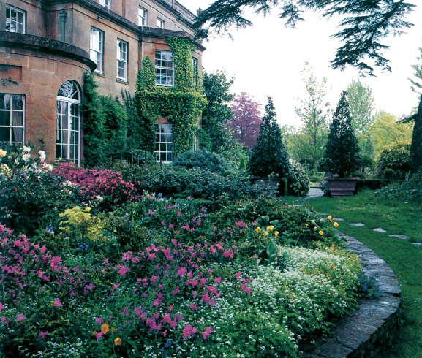

The Cutting Garden

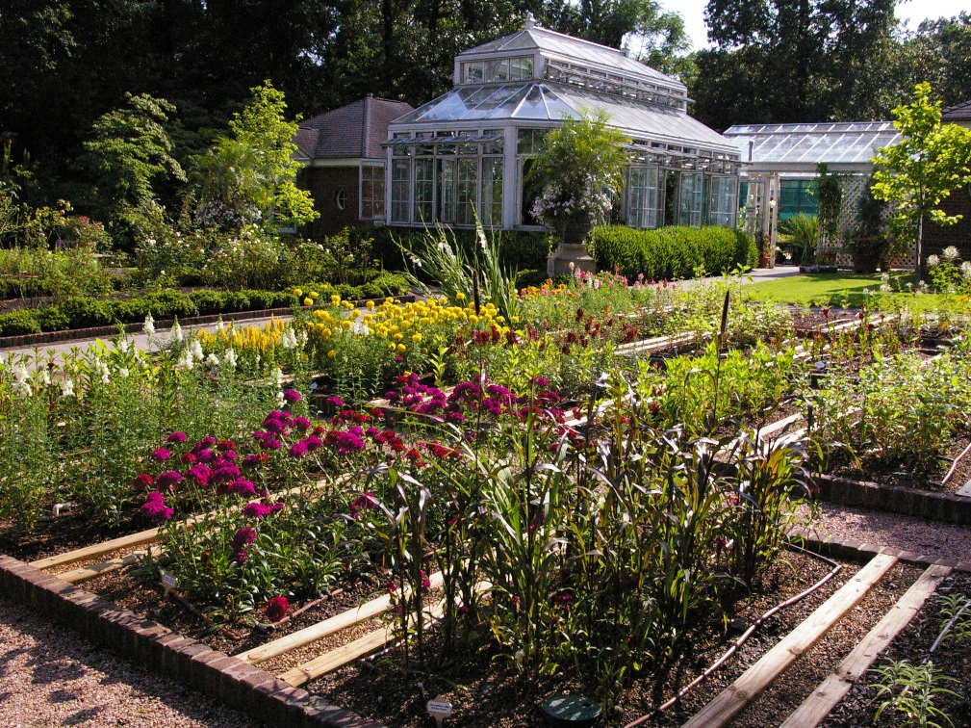

* For growing perennials meant to be brought indoors
* Should be laid out in a simple and practical manner
* Flowers should be cut properly
* Cut in morning or evening
* Plunge into a bucket of water immediately after cutting
* Perennials make excellent container plants, especially when combined with annuals, bulbs, and biennials
* Have the advantage of mobility
* Tend to dry out more frequently than gardens planted in the ground

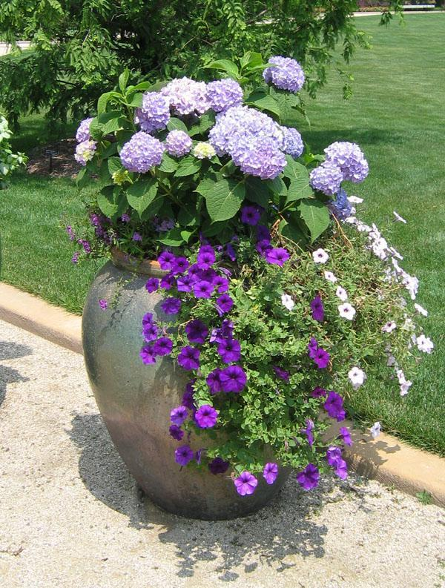

The Container Garden

|  |  |  |
| --- | --- | --- |
| **Scientific Name** | **Common Name** | **Growing Height** |
| *Achillea spp.* | Yarrow | 3 to 5 feet |
| *Aconitum spp.* | Monkshood | 3 to 5 feet |
| *Anemone x hybrida* | Japanese Anemone | 2 to 4 feet |
| *Aruncus dioicus* | Goatsbeard | 5 feet |
| *Asclepias tuberosa* | Butterfly Weed | 2 to 3 feet |
| *Aster* spp. | Aster | 2 to 5 feet |
| *Baptisia australis* | Blue False Indigo | 3 to 4 feet |
| *Centaurea montana* | Mountain Bluet | 2 to 3 feet |
| *Centranthus ruber* | Red Valerian | 2 to 3 feet |
| *Delphinium* spp. | Delphinium | 4 to 6 feet |
| *Dicentra spectabilis* | Old Fashioned Bleeding Heart | 2 to 3 feet |
| *Dictamnus albus* | Gas Plant | 3 feet |
| *Echinacea purpurea* | Purple Coneflower | 3 to 5 feet |
| *Echinops ritro* | Globe Thistle | 3 to 4 feet |
| *Helenium autumnale* | Helen’s Flower | 3 to 5 feet |
| *Heliopsis helianthoides* | False Sunflower | 3 to 4 feet |
| *Hemerocallis*spp. | Daylily | 1 to 4 feet |
| *Hibiscus moscheutos* | Rose Mallow | 3 to 5 feet |
| *Iris spp.* | Iris | 1 to 4 feet |
| *Liatris* spp. | Blazing Star | 2 to 4 feet |
| *Ligularia spp.* | Ligularia | 3 to 5 feet |
| *Linum perenne* | Perennial Flax | 2 feet |
| *Lobelia cardinalis* | Cardinal Flower | 2 to 3 feet |
|  |  |  |

Taller Perennials

|  |  |  |
| --- | --- | --- |
| **Scientific Name** | **Common Name** | **Growing Height** |
| *Lupinus hybrids* | Lupine | 3 to 4 feet |
| *Monarda didyma* | Bee Balm | 2 to 4 feet |
| *Paeonia spp.* | Peony | 2 to 3 feet |
| *Papaver orientale* | Oriental Poppy | 3 to 4 feet |
| *Phlox paniculata* | Garden Phlox | 2 to 4 feet |
| *Physostegia virginiana* | Obedient Plant | 2 to 4 feet |
| *Rudbeckia fulgida var. sullivantii* | Orange Coneflower | 2 to 3 feet |

Shorter Perennials

|  |  |  |
| --- | --- | --- |
| **Scientific Name** | **Common Name** | **Growing Height** |
| *Aegopodium podograria* | Goutweed | 12 inches |
| *Ajuga reptans* | Bugleweed | 6 inches |
| *Aquilegia* spp. | Columbine | 12 to 36 inches |
| *Arabis caucasica* | Wall Cress | 6 inches |
| *Armeria maritima* | Sea Thrift | 6 inches |
| *Artemisia schmidtiana* ‘Silver Mound’ | Silver Mound Artemisia | 12 inches |
| *Astilbe* spp. | False Spirea | 6 to 48 inches |
| *Aubretia deltoidea* | False Rockcress | 6 inches |
| *Aurinia saxatilis* | Basket-of-Gold | 6 to 12 inches |
| *Bergenia cordifolia* | Heartleaf Bergenia | 12 to 18 inches |
| *Brunnera macrophylla* | Siberian Bugloss | 12 to 18 inches |
| *Campanula carpatica* | Carpathian Harebell | 6 inches |
| *Cerastium tomentosum* | Snow-in-Summer | 6 to 12 inches |
| *Convallaria majalis* | Lily-of-the-Valley | 6 to 12 inches |
| *Dianthus* spp. | Pinks | 6 to 12 inches |
| *Dicentra eximia* | Fringed Bleeding Heart | 12 to 18 inches |
| *Doronicum orientale* | Leopard’s Bane | 12 to 18 inches |
| *Epimedium x rubrum* | Red Barrenwort | 9 inches |
| *Gaillardia x grandiflora* | Blanket Flower | 6 to 24 inches |
| *Galium odoratum* | Sweet Woodruff | 6 inches |
| *Geranium* spp. | Cranesbill | 6 to 36 inches |
| *Heuchera sanguinea* | Coral Bells | 12 to 30 inches |
| *Hosta* spp. | Hosta | 12 to 48 inches |
| *Iberis sempervirens* | Evergreen Candytuft | 6 to 12 inches |

Shorter Perennials

|  |  |  |
| --- | --- | --- |
| **Scientific Name** | **Common Name** | **Growing Height** |
| *Lamium maculatum* | Spotted Dead Nettle | 6 inches |
| *Lavandula angustifolia* | Lavender | 12 to 18 inches |
| *Liriope spicata* | Lily-Turf | 12 inches |
| *Nepeta x fassenii* | Catmint | 12 to 18 inches |
| *Oenothera macrocarpa* | Missouri Primrose | 9 to 18 inches |
| *Phlox subulata* | Creeping Phlox | 6 inches |
| *Saponaria ocymoides* | Rock Soapwort | 8 inches |
| *Scabiosa caucasica* | Pincushion Flower | 12 to 18 inches |
| *Sedum* spp. | Stonecrop | 3 to 12 inches |
| *Stokesia laevis* | Stoke’s Aster | 12 to 18 inches |
| *Veronica*spp. | Veronica | 6 to 30 inches |

Perennials Used As Groundcovers

* Goutweed–*Aegopodium podograria*
* Bugleweed–*Ajuga reptans*
* Wall Cress–*Arabis caucasica*
* Sea Thrift–*Armeria maritima*
* Beach Wormwood–*Artemisia stelleriana*
* Ginger–*Asarum spp.*
* Wild Ginger–*Asarum canadense*
* False Rockcress–*Aubrieta deltoidea*
* Snow-in-Summer–*Cerastium tomentosum*
* Leadwort–*Ceratostigma plumbaginoides*
* Green-and-Gold–*Chrysoganum virginianum*
* Lily-of-the-Valley–*Convallaria majalis*
* Yellow Corydalis–*Corydalis lutea*
* Red Barrenwort–*Epimedium x rubrum*
* Sweet Woodruff–*Galium odoratum*
* Cranesbill–*Geranium spp.*
* Hosta–*Hosta spp.*
* Chameleon Plant–*Houttuynia cordata*
* Variegated Yellow Archangel–*Lamiastrum galeobdolan var. variegatum*

Perennials for Shady Sites

* Bugleweed–*Ajuga reptans*
* Snowdrop anemone–*Anemone sylvestris*
* Columbine–*Aquilegia x hybrida*
* Jack-in-the-Pulpit–*Arisaema spp.*
* Wild Ginger–*Asarum canadense*
* European Wild Ginger–*Asarum europaeum*
* False Spirea–*Astilbe spp.*
* Japanese Painted Fern–*Athyrium nipponicum ‘Pictum’*
* Heartleaf Bergenia–*Bergenia cordifolia*
* Siberian Bugloss–*Brunnera macrophylla*
* Black Snakeroot–*Cimicifuga racemosa*
* Lily-of-the-Valley–*Convallaria majalis*
* Yellow Corydalis–*Corydalis lutea*
* Bleeding Heart–*Dicentra spp.*
* Foxglove–*Digitalis purpurea*
* Red Barrenwort–*Epimedium x rubrum*
* Ferns (various species)
* Sweet Woodruff–*Galium odoratum*
* Cranesbill–*Geranium spp.*
* Lenten Rose–*Helleborus orientalis*
* Coral Bells–*Heuchera sanguinea*
* Plantain Lily–*Hosta spp.*
* Deadnettle–*Lamium maculatum*
* Lilyturf–*Liriope spicata*
* Cardinal Flower–*Lobelia cardinalis*
* Virginia Bluebells–*Mertensia virginica*
* Japanese Spurge–*Pachysandra terminalis*
* Variegated Solomon’s Seal–*Polygonatum odoratum ‘Variegatum’*
* Lungwort–*Pulmonaria saccharata*
* Meadowrue–*Thalictrum spp.*
* Foam Flower–*Tiarella cordifolia*
* Globeflower–*Trollius europaeus*

Perennials for Moist or Wet Sites

* Goatsbeard–*Aruncus dioicus*
* False Spirea–*Astilbe spp.*
* Clustered Bellflower–*Campanula glomerata*
* Pink Turtlehead–*Chelone lyonii*
* Delphinium–*Delphinium elatum*
* Hibiscus–*Hibiscus moscheutos*
* Hosta–*Hosta spp*.
* Siberian Iris–*Iris sibirica*
* Japanese Iris–*Iris ensata*
* Ligularia–*Ligularia spp.*
* Cardinal Flower–*Lobelia cardinalis*
* Gooseneck Loosestrife–*Lysimachia clethroides*
* Virginia Bluebells–*Mertensia virginica*
* Bee Balm–*Monarda didyma*
* Obedient Plant–*Phystostegia virginiana*
* Rock Soapwort–*Saponaria ocymoides*
* Spiderwort–*Tradescantia x andersoniana*
* Globeflower–*Trollius europaeus*
* Great Blue Lobelia–*Lobelia siphilitica*
* Marsh Marigold–*Caltha palustris*
* Queen-of-the-Prairie–*Fillipendula rubra*

Perennials for Hot and Dry Sites

* Yarrow–*Achillea spp.*
* Wall Cress–*Arabis caucasica*
* Sea Thrift–*Armeria maritima*
* Silver Mound Artemisia–*Artemisia schmidtiana 'Silver Mound'*
* Silver King Artemisia–*Artemisia ludoviciana* 'Silver King'
* Butterfly Weed–*Asclepias tuberosa*
* Basket-of-Gold–*Aurinia saxatilis*
* False Indigo–*Baptisia australis*
* Mountain Bluet–*Centaurea montana*
* Coreopsis–*Coreopsis spp.*
* Globe Thistle–*Echinops ritro*
* Coneflower–*Echinacea purpurea*
* Sea Holly–*Eryngium amethystinum*
* Blanketflower–*Gaillardia x grandiflora*
* Daylily–*Hemerocallis spp.*
* Candytuft–*Iberis sempervirens*
* Red Hot Poker–*Kniphofia hybrids*
* Blazing Star–*Liatris spp.*
* Maltese Cross–*Lychnis chalcedonica*
* Primrose–*Oenothera spp.*
* Russian Sage–*Perovskia atriplicifolia*
* Orange Coneflower–*Rudbeckia fulgida var. sullivantii*
* Rock Soapwort–*Saponaria ocymoides*
* Stonecrop–*Sedum spp.*
* Lamb's Ear–*Stachys byzantina*
* Veronica–*Veronica spp.*

Perennials by Blooming Period

**March Blooming Perennials**

* Winter Aconite–*Eranthis hyemalis*
* Myrtle Spurge–*Euphorbia myrsinites*
* Snowdrops–*Galanthus nivalis*
* Christmas Rose–*Helleborus niger*
* Lenten Rose–*Helleborus orientalis*
* Bloodroot–*Sanguinaria canadensis*
* Spring Beauty–*Claytonia virginica*

**April Blooming Perennials**

* Bugleweed–*Ajuga reptans*
* Basket of Gold–*Aurinia saxatilis*
* Pasque Flower–*Pulsatilla vulgaris*
* Rock Cress–*Arabis caucasica*
* Purple Rockcress–*Aubretia deltoidea*
* Glory-of-the-Snow–*Chionodoxa luciliae*
* Old-fashioned Bleeding Heart–*Dicentra spectabilis*
* Fringed bleeding Heart–*Dicentra eximia*
* Candytuft–*Iberis sempervirens*
* Netted Iris–*Iris reticulata*
* Grape Hyacinth–*Muscari armeniacum, M. botryoides*
* Creeping Phlox–*Phlox subulata*
* Squill–*Scilla siberica*
* Early Tulips, Narcissus, and Hyacinth
* Virginia Bluebells–*Mertensia virginica*
* Jack-in-the-Pulpit–*Arisaema triphyllum*
* Marsh Marigold–*Caltha palustris*
* Trout Lily–*Erythronium americanum*
* Prairie Smoke–*Geum triflorum*

Perennials by Blooming Period

**May Blooming Perennials**

* Lady’s Mantle–*Alchemilla mollis*
* Common Columbine–*Aquilegia canadensis*
* Columbine–*Aquilegia x hybrida*
* Sea Pink–*Armeria maritima*
* Blue False Indigo–*Baptisia australis*
* Mountain Bluet–*Centaurea montana*
* Snow-in-Summer–*Cerastium tomentosum*
* Delphinium–*Delphinium x elatum*
* Cottage Pink–*Dianthus plumarius*
* Gas Plant–*Dictamnus albus*
* Leopard’s Bane–*Doronicum orientale*
* Peony–*Paeonia hybrids*
* Oriental Poppy–*Papaver orientale*
* Wild Geranium–*Geranium maculatum*
* Wild Ginger–*Asarum canadense*
* Golden Alexander–*Zizia aurea*
* Wild Sweet William–*Phlox divaricate*

**June Blooming Perennials**

* Astilbe–*Astilbe spp.*
* Silver Mound Artemisia–*Artemisia schmidtiana* ‘Silver Mound’
* Silver King Artemisia–*Artemisia ludoviciana* ‘Silver King’
* Carpathian Harebell–*Campanula carpatica*
* Peach-Leaf Bellflower–*Campanula persicifolia*
* Blanket Flower–*Gaillardia x grandiflora*
* Coral Bells–*Heuchera spp.*
* Rock Soapwort–*Saponaria ocymoides*
* Pincushion Flower–*Scabiosa caucasica*
* Stokes Aster–*Stokesia laevis*
* Spiderwort–*Tradescantia x andersoniana*
* Veronica–*Veronica spicata, V. longifolia*
* Pale Purple Coneflower–*Echinacea pallida*
* American Bellflower–*Campanula Americana*

Perennials by Blooming Period

**July Blooming Perennials**

* Fern-leaf Yarrow–*Achillea filipendulina*
* Common Yarrow–*Achillea millefolium*
* Blackberry Lily–*Belamcanda chinensis*
* Bugbane–*Cimicifuga simplex*
* Tickseed–*Coreopsis grandiflora*
* Threadleaf Coreopsis–*Coreopsis verticillata*
* Purple Coneflower–*Echinacea purpurea*
* Globe Thistle–*Echinops ritro*
* Sea Holly–*Eryngium amethystinum*
* Babys Breath–*Gypsophila paniculata*
* Helen’s Flower, Sneezeweed–*Helenium autumnale*
* Sunflower Heliopsis–*Heliopsis helianthoides*
* Hibiscus–*Hibiscus moscheutos*
* Hosta, Plantain Lily–*Hosta spp.*
* Blazing Star–*Liatris spicata*
* Sea Lavender–*Limonium latifolium*
* Cardinal Flower–*Lobelia cardinalis*
* Bee Balm–*Monarda didyma*
* Russian Sage–*Perovskia atriplicifolia*
* Garden Phlox–*Phlox paniculata*
* False Dragonhead–*Physostegia virginiana*
* Butterfly Weed–*Asclepias tuberosa*
* Rattlesnake Master–*Eryngium yuccifolium*
* Great Blue Lobelia–*Lobelia siphilitica*
* Culver-Root–*Veronicastrum virginicum*
* Pink Turtlehead–*Chelone glabra*
* Balloonflower–*Platycodon grandiflorus*
* Perennial Blue Salvia–*Salvia x superba*

Perennials by Blooming Period

**August Blooming Perennials**

* Monkshood–*Aconitum napellus*
* New York Aster–*Aster novii-belgii*
* New England Aster–*Aster novae-angliae*
* Leadwort–*Ceratostigma plumbaginoides*
* Garden Mum–*Dendranthema x grandiflora*
* Red Hot Poker–*Kniphofia* hybrids
* Joe-Pye Weed–*Eupatorium maculatum*
* Closed Gentian–*Gentiana andressii*
* Black-Eyed Susan–*Rudbeckia fulgida var. sullivantii ‘Goldsturm’*
* Showy Sedum–*Hylotelephium x ‘Autumn Joy’*

**September-October Blooming Perennials**

* Monkshood–*Aconitum*
* Aster–*Aster*
* Coreopsis–*Coreopsis*
* Bleeding Heart–*Dicentra eximia*
* Purple Coneflower–*Echinacea*
* Globe Thistle–*Echinops*
* Blanket Flower–*Gaillardia*
* Sneezeweed–*Helenium*
* Phlox–*Phlox*
* Balloon Flower–*Platycodon*
* Black-Eyed Susan–*Rudbeckia*
* Sedum–*Hylotelephium*

Other Uses

**Perennials That Attract Hummingbirds**

* Bugleweed–*Ajuga reptans*
* Columbine–*Aquilegia spp.*
* Common Columbine–*Aquilegia canadensis\**
* Butterfly Weed–*Asclepias tuberosa\**
* Bellflower–*Campanula spp.*
* Delphinium–*Delphinium elatum*
* Pinks–*Dianthus spp*.
* Bleeding Heart–*Dicentra spp.*
* Foxglove–*Digitalis spp.*
* Coral Bells–*Heuchera sanguinea*
* Daylily–*Hemerocallis spp.*
* Hibiscus–*Hibiscus moscheutos*
* Red Hot Poker–*Kniphofia hybrids*
* Lily–*Lilium spp.*
* Cardinal Flower–*Lobelia cardinalis\**
* Lupine–*Lupinus hybrids*
* Bee Balm–*Monarda didyma*

Other Uses

**Perennials That Attract Butterflies**

* Aster–*Aster spp.\**
* Common Yarrow–*Achillea millefolium\**
* Chives–*Allium schoenoprasum*
* Butterfly Weed–*Asclepias tuberosa\**
* Smooth Blue Aster–*Aster laevis\**
* Blackberry Lily–*Bellamcanda chinensis*
* Butterfly Bush–*Buddleia davidii*
* Purple Coneflower–*Echinacea purpurea\**
* Blanket Flower–*Gallardia x grandiflora*
* Autumn Joy Sedum –*Hylotelephium* x 'Autumn Joy'
* Lantana–*Lantana spp.*
* Blazing Star–*Liatris spicata\**
* Wild Bergamot–*Monarda fistulosa\**
* Catmint–*Nepeta mussinii*
* Sweet Marjoram–*Origanum vulgare*
* Phlox–*Phlox paniculata*
* Obedient Plant–*Physostegia virginianaa\**
* Black-Eyed Susan –*Rudbeckia fulgida* 'Goldsturm'
* Goldenrod–*Solidago*hybrids*

Other Uses

**Deer Resistant Perennials**

* Yarrow–*Achillea spp.*
* Monkshood–*Aconitum*
* Anemone–*Anemone*
* Columbine–*Aquilegi*
* Rock Cress–*Arabis caucasica*
* White Mugwort–*Artemisia lactiflora*
* Butterfly Weed–*Asclepias*
* Heartleaf Bergenia–*Bergenia*
* Bellflower–*Campanula spp.*
* Snow-in-Summer–*Cerastium tomentosum*
* Daisy–*Chrysanthemum*
* Coreopsis–*Coreopsis*
* Pinks–*Dianthus spp*.
* Coneflower–*Echinacea purpurea*
* Fleabane Daisy–*Erigeron* hybrids
* Joe-Pye Weed–*Eupatorium*
* Cranesbill–*Geranium spp*.
* Geum–*Geum*hybrids
* Helen’s Flower–*Helenium autumnale*
* Hellebore–*Helleborus spp.*
* Dame’s Rocket–*Hesperis matronalis*
* Hibiscus–*Hibiscus spp.*
* Candytuft–*Iberis sempervirens*
* Iris–*Iris*
* Maltese Cross–*Lychnis chalcedonica*
* Bee Balm–*Monarda didym*
* Peony–*Paeonia* hybrids
* Russian Sage–*Perovskia atriplicifolia*
* Jacob’s Ladder–*Polemonium caeruleum*
* Foam Flower–*Tiarella cordifolia*
* Orange Coneflower–*Rudbeckia fulgida var. sullivantii*
* Salvia–*Salvia spp.*
* Soapwort–*Saponaria ocymoides*
* Sempervivum–*Sempervivum*

Other Uses

**Deer Resistant Perennials**

* Goldenrod–*Solidago* hybrids
* Speedwell–*Veronica spp.*
* Spanish Bayonet–*Yucca filamentosa*

Illinois native plants or cultivars marked with *.

Source: University of Illinois Extension, *Gardening with Perennials* [*http://urbanext.illinois.edu/perennials/specific.cfm*](http://urbanext.illinois.edu/perennials/specific.cfm)