**Bangor Boats**

Bangor boats away, we have no time to stay! (*Bounce.*)   
So row your boats, row your boats (*Make rowing motion*.)   
Bangor boats awaaay! (*Bounce again, and lift baby up.*)

**Toot Toot Beep Beep** by Emma Garcia  
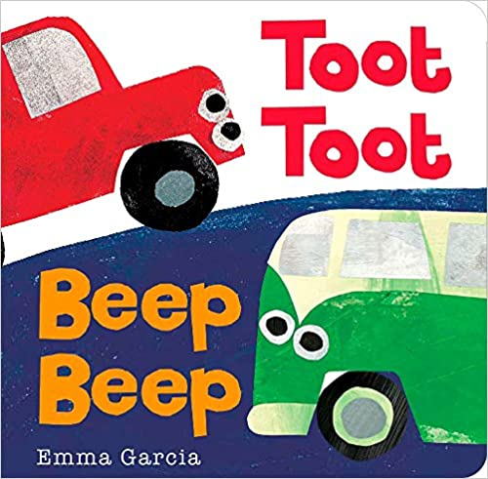

Lap Bounce

Book of the Day

Similar to animal sounds, transportation sounds help babies hear the smaller sounds in words.

**Motorboat**

**(***Lay baby on back and alternate pushing legs back and forth faster and faster. End with a tickle****!*)**

Motorboat, motorboat go so slow.   
Motorboat, motorboat go so fast,   
Motorboat, motorboat turn on the gas! VROOOM!

Early Literacy Tip

Action Rhyme

**Here We Go**  
  
Here we go up, up, up  
Here we go down, down, down  
Here we go shake, shake shake!  
Here we go round and round!

Shaker Song