**Hi-Five Animals** By Ross Burach 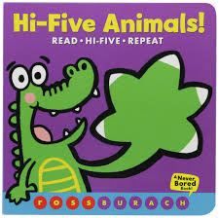

**Bumpin’ Up and Down**  
Bumpin' up and down in my little red wagon. (*bounce*)   
Bumpin' up and down in my little red wagon.   
Bumpin' up and down in my little red wagon, Having so much fun.   
**Other Verses:**   
Turning the corner in my…(*tilt baby)*  
Going downhill in my…*(Face baby downward)*

Lap Bounce Action

Book of the Day

**Johnny, Johnny, Whoops**  
Johnny, Johnny, Johnny, Johnny.  
Whoops! Johnny.  
Whoops! Johnny.  
Johnny, Johnny, Johnny, Johnny.

Take your baby’s hand in yours with his palm open and fingers facing up. Starting with his pinky, tap each of his fingers one at a time with your index finger and say “Johnny.” Stop after you touch his index finger and then slide your finger down the side of his index finger and up his thumb as you say “Whoops!” After you slide up to his thumb tip, say “Johnny.” Then, repeat in the other direction back to his pinky.

Early Literacy Tip

Books like “Hi-Five Animals” do a great job of integrating multiple components of early literacy—reading and playing!

Lap Game