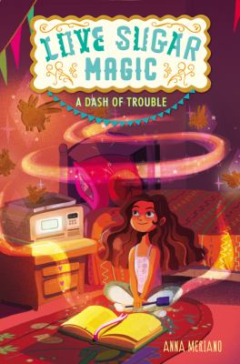

A magically sweet story set in a Mexican-American family bakery.
- This book is set in a town called Rose Hill, Texas, which Leo describes as “in-between sort of place” that isn’t “important enough, or interesting enough to compete with” the big cities. What is Leo’s hometown like? How would you describe your hometown?

- “Sisters are always hanging around, until suddenly they left you behind” (chapter 2). How would you describe Leo’s sibling relationships? Are these relationships similar or different from your own family relationships, or sibling relationships in your friends’ families?

- Does your family pass any special traditions or knowledge from one generation to the next?

- Leo, who does not speak Spanish, sometimes is frustrated when her family speaks Spanish around her. Why does her family do this?

- In chapter 3, we learn that Caroline is “the kind of person who used the weekly words in real life” and Brent is “the type of person who did controlled experiments in real life.” What kind of person are you?

- In chapter 7, Isabel explains to Leo that “our special family power comes from the magic of sweetness; sweetness from love and sweetness from sugar.” What is unique about this power? How does Leo’s family use it? How are brujas different from witches?

- Even though her sisters warn her that magic can be dangerous, Leo is so eager to start that she can’t concentrate on anything else: “her thoughts kept wandering to the recipe book under her bed. She didn’t know what was worse, the guilty feeling of a secret or the impatience of wanting to try her next spell” (chapter 10). Which of those emotions would be most challenging for you?

- Why does Leo start casting spells on her own? What causes her magic to go awry? Why is she reluctant to ask for help?

- If you had a magical ability, what would it be? How would you use it?

- Leo “had always thought that she had trouble making friends because it was such a difficult thing to do; she had never considered that there might be friends to be had if she had looked a little harder” (chapter 15). What else does Leo learn about friendship in this book? Have you ever made an assumption that turned out not to be true?

More Books Like A Dash of Trouble
Allie, First at Last by Angela Cervantes
Born into a family of over-achievers, fifth-grader Allie Velasco has never finished first in anything, but is determined to win a photography contest. Although this is a realistic novel, it shares the same themes of friendship and family as A Dash of Trouble.
- Request the print book.
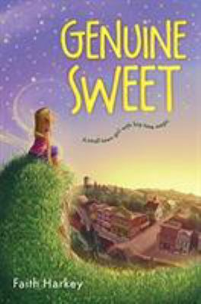
Genuine Sweet by Faith Harkey
12-year-old Genuine Sweet inherited the ability to grant any wish except her own. With help from new friends, Genuine learns the difference between wishing for and building a better life and building one.
    - Request the print book.
    - Download the e-book.
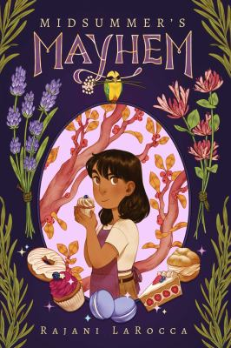
Midsummer’s Mayhem by Rajani LaRocca
Loosely based on Shakespeare's A Midsummer Night's Dream, 11-year-old Mimi Mackson entangles herself and her family with mischievous fairies after entering a baking contest.
- Request the print book.
- Download the e-audiobook.
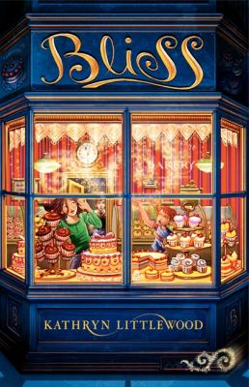
Bliss by Kathryn Littlewood
Twelve-year-old Rose Bliss wants to work magic in her family's bakery as her parents do, but when they are called away and Rose and her siblings are left in charge, the magic goes awry.
- Request the print book.
- Download the e-book.
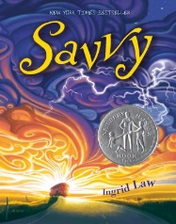
Savvy by Ingrid Law
Recounts the adventures of Mibs Beaumont, whose thirteenth birthday has revealed her "savvy"--a magical power unique to each member of her family--just as her father is injured in a terrible accident.
- Request the print book./ Request the print audiobook.
- Download the ebook. / Download the e-audiobook.
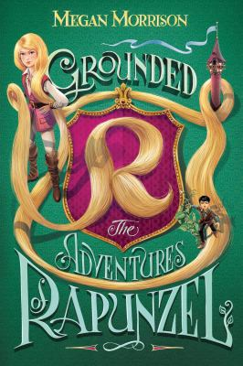
Grounded by Megan Morrison
When Jack climbs into Rapunzel’s tower to steal an enchanted rose and hints that Witch is not telling the whole truth, Rapunzel leaves the tower for the first time.
- Request the print book.
- Download the ebook.

